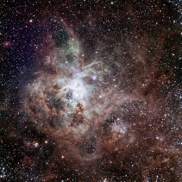
What will we explore this week? 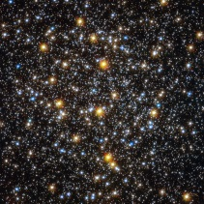
Epiphany!
The magi followed the star to Bethlehem to find the baby Jesus. So I asked them…
What is a star? Are they all the same size? What color is a star? What do we know about stars?!
I wrote down a bunch of different ideas from the class. They were pretty clever.
We worked on a special art project for the bulletin board in our hallway. Van Gogh was a famous painter and we recreated our own “Starry Night” paintings. They look “out of this world” .
We still have a few topics to cover on stars but as we go through space please feel free to have your child bring in any books or topic items they may want to show us.
Tues. 1/15: Pacific Science Center Van Visit – All Day / 6:30 AM
Wed. 1/16: 8:00 AM Muffins with Mom / 8:40 AM Chapel led by 2nd Grade
Mon. 1/21: No School and No ESC – MLK Jr. Day
Re-Enrollment for Fall 2019 – January 15-21
Re-enrollment will begin January 15th to the 21st for currently enrolled families. You will receive our re-enrollment packet next Tuesday, January 15th in the communication envelope with information on enrolling through K12online. All students will receive a new student number and access key.
On January 28, 2019 we will begin processing new applications from the community. If you have any questions about re-enrollment, please email or call the school office or admissions director at sheit@hopeseattle.org.
Preschool Open House, Tuesday, January 15, 6:30 PM
Invite your friends, neighbors and family members to check out our Preschool Open House on Tuesday, January 15 at 6:30 pm. Hope School offers 3 year-old and 4 year-old play-based programs with two to five day options and an option for extended care. Bring your little one and see first-hand the learning and fun students have here at Hope.
Science on Wheels sponsored by PTH – January 15
Our Science on Wheels program that is coming to Hope on Tuesday, January 15 is just one of the awesome programs that are possible because of you! Funds raised through our Parents and Teachers of Hope are used to bring this interactive Science program to Hope School. Students from preschool through grade 8 will attend an assembly, have class lessons in their portable Planetarium and/or explore the hands on Space Odyssey exhibits. Thank you PTH.

