Orca class Newsletter
September 6-9 2016

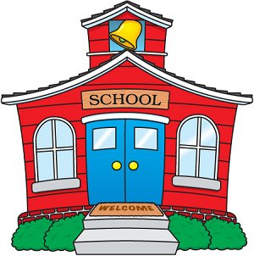
Hi Parents!
We’re off to an awesome start!!! I love seeing all the precious smiles. It makes my heart feel full when the kiddos come up to me and give me a huge hug! We are a family and it isn’t taking much time for them to feel God’s love wash over all of us. Such a blessing.
The kiddos have been exploring the classroom and getting to know Mrs. Gardner and I as well as getting to know each other. We introduced Fruits of the Spirit last week. They learned the Fruits of the Spirit song which is so helpful for a reminder of how we should treat one another. They are truly picking up on the kind actions we sing about. Love, Joy, Peace, Patience, Kindness, Goodness, faithfulness, Gentleness, and Self Control. Needless to say, your wee ones are a special gift.
Coming up this week…
We will continue with introductions to our weekly structure. We begin our monthly calendar, days of the week song and weather report all led by our special helper for the day! Our unit of focus will be, All About Me! We will take a look at how God makes us all different and special. We will graph some of our differences . We took pictures and measurements last week so I need to catch up with some of the kiddos who were out of town. This week will be a lot of catch up so I have all my students on the same page.
We have our First Shining Star this week! Hadley Read!!! The Reads will be providing snack this week. As I mentioned I am working on the snack/ shining star snack list this weekend. Just a little info on this topic, the reason it takes some time is because I try my hardest to place each family somewhere near their little one’s birthday. However, sometimes it just won’t
work out well with the schedule. Please know I will do my best. If your sweetie needs a special treat or snack in place of what is provided, please send something in with them marked with their name.
If your child is in 2 by 2 Friday (that is what I call the class because it’s based on Project Wild curriculum which has a lot of emphasis on animals in the wild) class I have a few things I will share. This is a smaller group of students because it’s only me teaching. There are a few differences in our Friday class compared to our Mon- Thurs class. Since we have a smaller crew I’m able to take them to our school library (on campus) and we have two recesses, one being in the garden, instead of one. They always begin the school year with some confusion about Friday class but they eventually get the hang of things and look forward to it. I’ll post some info each week about the animals they choose to learn about!

This week…
Art: Decorating our names, mini Bibles, Painting
Math: Numbers, counting, graphing
Science: self-exploration sniff pictures
Literacy: The Bible is God’s true word, Beginning school, all about me, letter bean bag toss
Writing: We will begin writing our names
Sensory: sand and funnels with people
Outside: Garden/ big toy
Dramatic Play: Kitchen, lunch boxes, baby dolls

God bless you and keep you all in His love!
Working for Him,
Mrs. Seraile

