THE FAB TEN EXCERCISES

1: Do each body weight exercise 10 times for 3 sets
2: Take a 30 second rest between each set.
3: Plank exercises hold for 30 seconds 3 sets with a 30 second rest between planks
Make sure to be in control and to not rush your movement! Correct form will give your body the most benefit!
Adjust reps and sets as needed for you to have success!
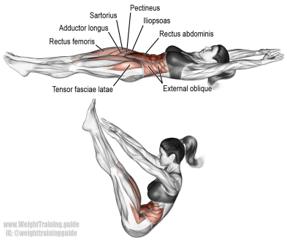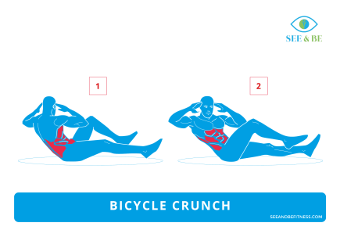
1: V-Ups 2: Bicycle Crunches
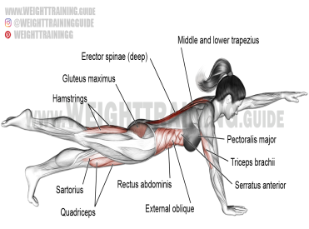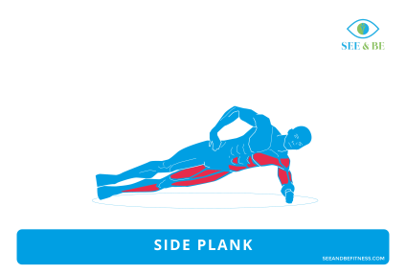
3: Plank Bird Dog 4: Side Planks

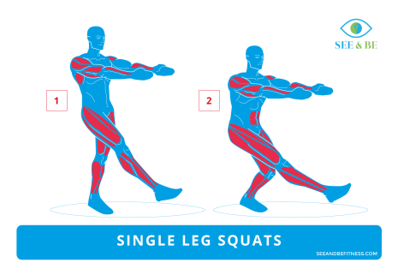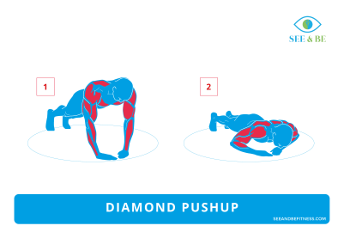
5: Single Leg Squats 6: Diamond Pushups

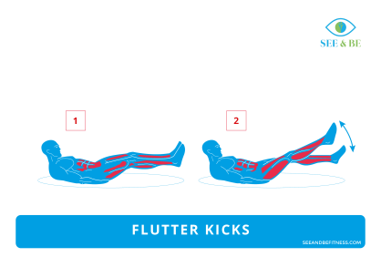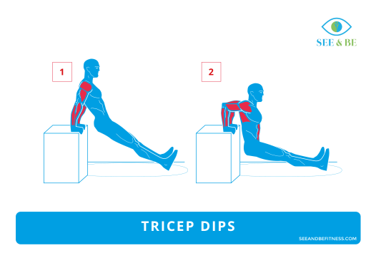
7: Flutter Kicks 8: Tricep Dips

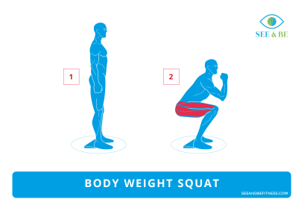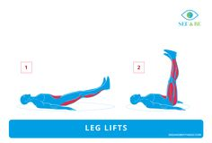
9: Squats 10: Leg Lifts

